Abstract

The Origin of Life (OoL) debate, abiogenesis vs. Intelligent Design (ID), has centered mainly around the abilities of Natural Causes (NC) to create the molecules, information, and design with the associated complexities and coherence found in life. The lack of these abilities suggests ID. More recently, both abiogegists and ID proponents agree that machines similar to those designed by humans are abundant in life. This paper reveals that machines are an added entity to a system that, when running their process, uniquely perform work determined by a mind as opposed to natural causes acting alone. This process involves the processing of specified information. Since processing information is a form of intelligence, intelligence is invoked in the very process of living, not just its design.
This work reveals a singular process that creates work specified by a designer based on science, logic, experience, and observation. This theory can be summarized as follows:
The work performed by natural processes uses the system's stochastic, unguided, naturally existing energy to perform work directed only by the laws of physics. By comparison, machines are separate, added entities to a system that perform work specified by their intelligent designers, which is impossible by natural causes alone. Machines, as defined herein, including those created by humans and those found in life, are assemblages of unnatural mechanisms added to a system that runs an unnatural, separate process, performing specified work utilizing unnatural, elevated, specified energy. The process steps include acquiring specified information, then processing this information using an algorithm, and finally using this result to control specified energy to perform specified work on the system. This process adds a specified configuration of matter, energy, and specified information to the system to achieve designer-specified results compared to a natural system that does not contain a machine.

This posited machine theory is intuitive and easy to understand using examples. However, the mechanisms that implement these functions can be highly complex at the individual machine and system levels, utilizing many-layered, embedded, and shared machines powered by unnatural energy sources. James Clerk Maxwell’s demon is the only previous description of machine functions that an exhaustive literature search has uncovered, which is surprising considering the concept's simplicity and observability. His genius envisioned an entity that could overcome the 2nd law of thermodynamics by performing the process steps he described. This paper posits the machine theory detailed herein that defines the demon’s actions.

Therefore, we can distinguish between natural causes and machine causes as the two causal mechanisms that account for all physical creations we observe, except for humans’ ability to abstract.
In addition, this paper shows that creating a machine, setting its initial conditions, and starting the machine's specified process requires the work of a machine. These facts reveal numerous causal circularities.
Machine Theory reveals that achieving specified results requires an operating, that is, actionable, and intelligent (processed, specified information) process, not static, intangible things like information, complexity, coherence, etc. The static arguments are all true, and all one should need to know, but they leave room for doubt. So, Machine Theory puts the challenge to abiogenesis to demonstrate natural causes performing specified work. Or, on the flip side, demonstrate a life’s existence without running machines. Or a running machine created by natural causes. Machine Theory forces one to face the fact that machines and life are designed, dynamic entities that require other “abstraction-capable dynamic entities” to design, create, and start another machine’s running process. Stated differently, Machine Theory compels one to consider the added consequences that the dynamics of machines impose compared to their statics. There is no such thing as a static running machine.
This theory can be disproved by any simple example of natural causes performing specified work, such as turning on or off a light when commanded by an intelligent entity.
The laws of physics (the 2nd law of thermodynamics), observation of man-made and life machines, and the logic of creating specified work validate the machine theory presented here.
Ultimately, this theory is fundamental to understanding life and human-created machines, and it should be part of the curricula for engineers and biologists.

What is a Machine?
Webster's definition is "… a device for performing a task," Collin's definition is "…a piece of equipment that uses electricity or an engine to do a particular kind of work," Macmillan's definition is ".. a piece of equipment that does a particular job," Dictionary.com's definition is "an apparatus … used in the performance of some kind of work," Britannica's definition is "device, having a unique purpose, that augments or replaces human or animal effort for the accomplishment of physical tasks." Of course, these sources included other definitions. However, "performing a purposeful task" is the common theme.
"A task," "particular," "some kind," or "unique purpose" are descriptors of a specified purpose. Only a mind (Webster: "the element or complex of elements in an individual that feels, perceives, thinks, wills and especially reasons") can specify (Webster: "to name or state explicitly or in detail") anything. A designer’s mind determines (specifies) the defining parameters of a machine's work.
I posit that limiting the definition of a machine to those devices that perform specified work is appropriate because this description fits the devices we most commonly think of and formally define as machines. Additionally, this definition provides a clear and identifiable dividing line between natural (no machines involved) and specified creations (machines involved). In addition, devices such as levers and pulleys are often referred to as machines, but they should be more accurately described as mechanisms or tools used in or by machines. However, a tool, such as a screwdriver, used by a human, by definition, becomes a new machine with enhanced capabilities.
The genesis of Machine Theory results from observing human-designed machines and machines in life. Engineers have been designing machines for centuries, focusing on the mechanisms that make them work, rather than considering the processes involved, which is the opposite of reality. Learning that machine work is the result of a process adds the necessity to consider the specified (machine) work required to set the initial conditions of a second machine and to initiate the running process of the second machine, a fact not addressed in current OoL discussions.
Specified work requires several functionalities not present in natural systems and other devices, such as mechanisms and tools. An extensive literature search has revealed only one description of the machine process. It is James Maxwell’s “demon.” Here is the text from the book “The Man Who Changed Everything, The Life of James Clerk Maxwell” that explains the actions of the demon that would cause heat to flow from cold to hot:
“The Theory of Heat also introduced readers to James’ most extraordinary invention: an imaginary molecule-sized being who could make heat flow from a cold substance to a hot one, thereby defying the second law of thermodynamics. This was Maxwell’s demon. The little creature soon took on legendary status and lived up to its name, perplexing the world’s best physicists for 60 years.
Playful though it was, James’ idea is also a profound thought experiment of the kind that Einstein later made his own. The demon guards a small hole in the wall separating two compartments of a container filled with gas. He has a shutter over the hole, which he can open when he wants to. Molecules in both compartments are moving in all directions. Their average speed (strictly, the average of the square of the speeds) determines the temperature of the gas (the faster, the hotter), and to start with, this is the same on both sides of the wall.
According to James's own law for the distribution of the velocities, some molecules are moving slower than the average speed and some faster. When the demon sees a fast molecule in the right compartment approaching the hole, he opens the shutter briefly and lets it through to the left side. Similarly, he lets slow molecules pass from the left compartment to the right. The rest of the time, he keeps the shutter closed.
With each exchange, the average speed of molecules in the left compartment increases, and that in the right compartment falls. But there will still be some molecules in the right compartment traveling faster than the average speed in the left, and when one of these approaches the shutter, the demon lets it through. In the same way, he continues to let slow molecules through from left to right. So the gas in the left compartment gets steadily hotter while that in the right compartment gets colder.
The demon is making heat flow from a colder gas on the right to the hotter gas on the left, thus defying the second law of thermodynamics, which says that heat cannot flow from a colder to a hotter body. By the same token, the demon is providing the means of making a perpetual motion machine: the temperature difference between the gasses could be harnessed to make a machine do physical work: the machine would keep going until the temperature difference fell back to zero.”
The demon, monitoring the molecules and operating the shutter over the hole in the wall, constitutes the machine. When the demon “sees a fast molecule in the right compartment approaching the hole…” he is acquiring the information needed to determine when to open the shutter. This action is a machine’s first process step, acquiring information, as shown in Figure 2.
Then, the demon processes this information, the second function shown in Figure 2. He does so by keeping a running average of the molecules’ speeds on each side of the shutter. Then, when the demon observes an approaching gas molecule on the hot side of the shutter with a lower speed than the average cold side molecules, he determines when to open the shutter and vice versa. This action represents processing the information gathered using an algorithm.
Finally, based on the algorithm result, whether or not to open the shutter, the demon physically moves the shutter, represented by the actuation function shown in Figure 2. Maxwell conceived the demon as a natural entity that would defy the 2nd law of thermodynamics if the demon did not consume energy. He did not think of the demon as a machine that consumes specified, raised energy to overcome the 2nd law, but he was correct regarding the functionalities shown in Figure 2. Therefore, the demon, plus the shutter and hole in the wall, coupled with the unnatural energy the demon uses to perform this work, is a machine. So, one can reasonably consider Maxwell the father of the Machine Theory concept presented here.

Definitions
The discussion about natural vs. machine creations requires clarity of the terminology used. The problem starts with the term machine, as explained in the “What is a Machine?” section above. Machine Theory only applies to the “device that performs specified work” definition.
Specified means “specified by an intelligence.”
Another term that needs precision for Machine Theory is information. One can think of information used in Machine Theory as a token for specified differences. For example, machine designers use information to document the design of a machine, including instructions on how to build it, set its initial conditions, and start the machine’s process. Additionally, a machine’s first process step is to gather the information that defines the conditions specified for its operation. The time and location specificity of the work is implicit and defined because of the process’s current time and location. The time and place specificity is essential because natural causes can sometimes mimic specified work, e.g., weather raising water, but cannot do so with other specified conditions.
Therefore, all information associated with machine theory is specified, including its design, construction, initial setup, start of the machine process, and the information used by the machine, such as time and location, as well as the work performed by it.
Two levels of intelligence are arbitrarily identified for purposes of this Machine theory discussion, coming from an engineer, not a philosopher. The first is algorithmic, meaning intelligence that results from using virtually any algorithm to produce a mind-created result based on the information provided. The second is called abstraction, which is not used for performing work on a system, but rather serves as a catch-all for activities such as theorizing, designing, and inventing, and is based on creating information rather than processing it. Machine Theory identifies and clarifies this distinction.
Other definitions are provided where appropriate.

Differences Between Systems With and Without Machines
This section will use diagrams to illustrate the state change (work) causal mechanisms in natural systems compared to systems that contain machines. Parts of the system that refer to the energy in these diagrams that cause natural work are colored orange, and specified energy references are colored red.

Natural Systems
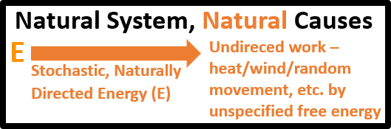
The laws of physics, without any intelligent mechanism, coupled with the available stochastic, naturally directed energy, determine the work performed in a Natural System, as illustrated in Figure 1. State changes will occur immediately when this energy exceeds the activation energy, and the free energy change (ΔG) for the state change is less than zero, the Gibbs criterion for a spontaneous reaction (ΔG < 0). We know from physics that random energy causes state changes in a thermodynamic "downhill" direction, meaning a more stable equilibrium, higher entropy, and lower energy, without any mechanism to implement intent. Some argue that energy entering the system from the outside could create thermodynamic "uphill" work. As thermodynamicist A. McIntosh shows and says: "Even if …. one had a completely open system, no amount of matter or energy exchange without information exchange would alter the fundamental finding concerning spontaneity of chemical reactions.
Figure 1. A Natural System whereby all work performed within the system is due to the availability of stochastic, naturally directed energy necessary to perform the work. Only the state of the system and the laws of physics determine outcomes.
This physics model explains all material entities in the universe, including galaxies, suns, solar systems, planets, black holes, etc. But it does not explain life and life's creations.

Why Can't Natural Causes Perform Specified Work?

The Logical Explanation
Let's say our machine's purpose is to control a room's temperature. Naturally, such a machine must know the setpoint and current temperature. Therefore, there must be a means to acquire this information, such as sensors or electrical potentiometers.
Then, some mechanism must process this information based on an algorithm:
Room Temperature (RT) = Setpoint Temperature (ST), no action
RT > ST, move heat from inside to outside the room
RT < ST, move heat from outside to inside the room
Then, there must be a means to signal a mechanism that can interpret the “move heat” information, because natural causes have no means or specified energy source to acquire, process, or add or remove heat from the room on demand. Therefore, some "unnatural" energy sources and mechanisms must be available to perform this specified work.
Natural causes have no means to perform a specified action if the specified action violates the laws of physics or includes a specified place or time. Physics and specification come from two different realms.
Are there any other means to achieve specified results? Logic and observation suggest a negative answer, but this is not conclusive proof. Part of the purpose of expounding machine theory is to challenge it.

The Observational Explanation
We find “unnatural entities” to acquire information, process information, and control an energy source to perform specified work when we carefully inspect the mechanisms within all devices defined as machines. And we observe these mechanisms only in life and in man-created machines. However, we do not understand all the mechanisms we observe in life. However, we observe the information flow, the specified work being performed, and the raised energy involved in processes that we understand. However, as discussed earlier, we do not understand some processes, such as the growth of multicelled organisms.

The Theoretical Explanation
Only a “Maxwell’s demon” functionality, plus raised energy added to a system, can achieve specified results. Natural causes cannot create the specified energy required to perform the signal acquisition, signaling, and processing, or perform the specified work on the system. For example, the simplest signal processing action is a logic gate function, such as a simple yes-or-no answer to a question. The yes and no answers must be represented as separate states in the machine and stay there until the question is reasked. Such action is impossible in a natural system for two reasons. First, natural causes have no mechanism to respond in a specified manner to information that comes from a different paradigm. Second, because of the 2nd law of thermodynamics, the energy flow to force a yes to no is the opposite direction from a no to a yes, unlike the energy flow in a natural system, which, if available at all at any given location and point in time, occurs only in one direction.
Regarding the work on the system, everyone knows that a rock will not go uphill on demand. However, a machine, specifically a power shovel, can accomplish this. The engine or motor in the power shovel provides the energy, which is then utilized by the mechanisms that control this power. Natural systems lack these characteristics.

Systems Containing Machines
Adding specified causes to a system's natural causes (Figure 1) requires considerable added functionality to implement intent that one does not find in the natural only world, as seen in Figure 2.
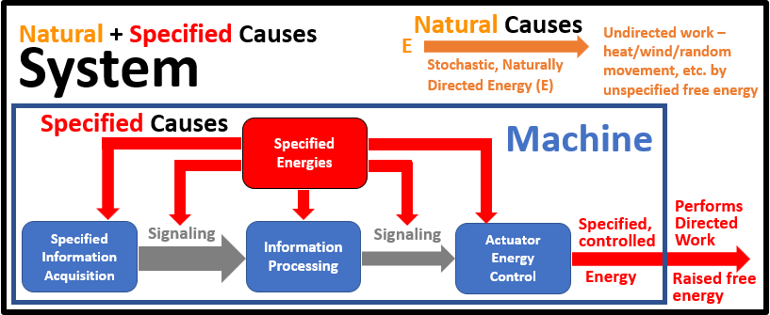
Figure 2. shows the added, separate, identifiable mechanisms that perform the functions of (shown in blue), Acquisition of Information, Information Processing, Actuation, and Source of Specified Energy (shown in red). Additionally, a means to transfer information between the functional modules (shown in grey) must exist.

What Does it Take To Perform Specified Work?
Specified work causes actions to occur as a function of specified conditions. As shown in Figure 2, machines implement this capability by acquiring the information that specifies these conditions. Next, the machine must process this information to determine the action required to fulfill the specification. Then, the machine performs this action on the system by a mechanism (actuator) using the processed information to control specified energy. The heat pump described earlier is an example of this process.
Acquiring, processing, and acting upon information is a step-by-step process. These steps utilize material mechanisms that occupy space, require time, and consume energy when running, compared to natural processes, even when the machine is not actively working on the system.
Natural processes are different. There are no mechanisms to gather and process information. The space, specified energy, and time to run the specified machine process steps are non-existent. There is no energy or mechanism to perform specified work, such as moving something uphill or causing heat to flow from cold to hot according to a specification. The only specified work we experience is the work of machines, which can reverse the general trajectory of natural work. And the only machines we observe come from life, in the form of life itself and human-designed machines.

What is Not a Machine?
A machine is a device that implements algorithmic intelligence in the material world. However, it cannot implement abstract intelligence.
A machine’s first process step is to acquire the information needed by the machine to specify the work required. Designing a machine is a different process. Instead, the designer must conceive the desired end. In other words, a machine designer must be able to think abstractly, meaning “the quality of dealing with ideas rather than events,” according to Oxford Languages. We humans are the only entity we observe that has this ability. But we do not understand how to implement this ability, so we cannot design entities with the ability to abstract. Machine Theory does not apply to abstraction; it only applies to the process required to perform designer-specified work on the system it resides in and, therefore, is limited to human-designed machines and those found in life, except for humans’ ability to abstract.

This understanding of machines’ limitations negates the idea of Kurzweil’s Singularity, making the fear that artificial intelligence (AI) will dominate the world in the future unfounded. Humans possess the knowledge and ability to create machines that perform work, including the creation and manipulation of information, but cannot abstract, such as theorizing, designing, and inventing.

However, Machines are the entities that reign over natural causes to create specified work and are the basis of Machine Theory.

Machine Functions
This section will examine each functionality in detail. The following diagrams show the functions implemented by the machine’s running process required to achieve the specified results. Machine designers can implement these functions using numerous technologies and mechanisms limited by the designer’s creative ability and available technology. Therefore, one needs diagrams (or tables) like the mousetrap and computer figures to correlate the function to the mechanism.

Acquisition of Specified Information
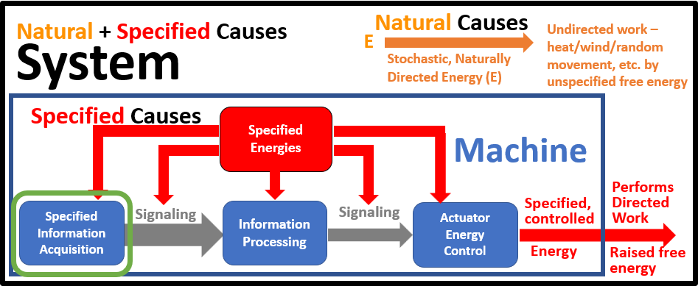
The role of a machine is to conduct specified work. Specified means the work is conditional; therefore, the machine must know these conditions. Each condition is a parameter the machine must acquire to perform the specified work. In addition, the machine’s mechanism(s) may require knowledge of internal parameters to function, e.g., an engine needs to know the crankshaft angle to open and close intake and exhaust valves, and to inject and ignite the fuel. This section discusses the various aspects of information acquisition.
Figure 3. This is a System of a diagram that includes a machine. The machine diagram shows the functional elements necessary to perform specified work. The green circle highlights the information acquisition function discussed in this section

Information Confusion
"…. the word information is an abstract noun."
Information is distinctions represented in the mind by language, symbols, images, tokens, etc. Specified information means that a mind has defined the meaning of the information involved, which generally has well-established meanings documented by dictionaries, etc. As previously mentioned, information has two types from the Machine Theory standpoint: unspecified and specified. Unspecified information is related to natural causes because state variables of a system are information, but they are not specified by anything. On the other hand, the designer defines the specified information to have meaning and function, which is used to implement the machine's specified work.
Here is an example to clarify the relationship between specified and non-specified information. Referring to the room temperature control system mentioned earlier, the room temperature is a natural state variable. The temperature control system includes a sensor to measure this temperature, and its information output, which the designer calls “room temperature, " is now specified information. Inside the system (room), the temperature is natural, unspecified. However, inside the machine is a specified proxy for this temperature, say a voltage level, which is specified information.
However, there are many other types of information related to machines. Engineers create machines. The creation process involves several steps that require specific information for various purposes, often in different formats. The creation steps of conception (purpose), concept design, performance specification, detail design and documentation, bill of materials, assembly instructions, prototype test procedure and results, production documentation, etc., are examples of information and are in the form of standard language, drawings, etc. documented in standard methods on paper, computer files, etc. The interpretation of the tokens, symbols, etc., is predefined in meaning. This process allows others to obtain and process the materials and manufacture the machine. These are all examples of specified information related to machines that do not exist in the natural world.
However, a machine uses specified information to perform its function, rather than providing the information used to create it. The designer designates physical states to have a stated meaning. For instance, using the mousetrap example, the specified information “no mouse” changes to “mouse present” when the bait moves, causing the treadle to move. And treadle movement sends a signal: “Release the hold-down bar," etc. The designer determines these states and their meaning. There are few standards for machine information nomenclature except for machines that use computer or communications technology.
This paper focuses on the role of information used in a functioning machine. Still, it is essential to understand the requirement for specified information to create and initiate the machine process, as it does not exist in a natural system.

Sources of Machine Information
Machine designs may require information from several sources, as shown in Figure 4.

Information From Other Machines
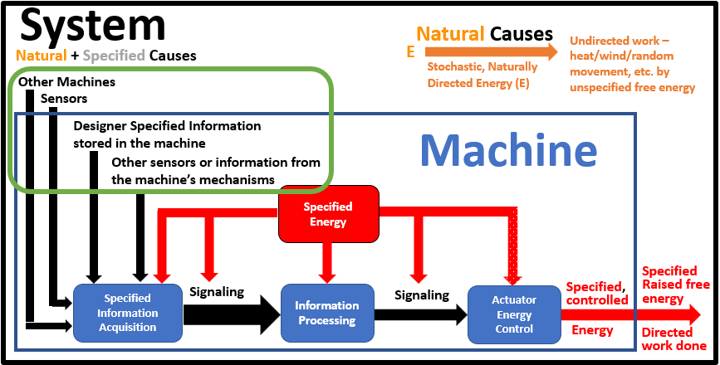
Machine operation is a process, and often, a machine performs a step in a higher-level machine process that requires an exchange of information. The cell phone is an excellent example as it has all the following embedded machines that gather specified information for use by other application including: accelerometer, magnetometer, gyroscope, temperature sensor, light level sensor, Bluetooth, WiFi, USB, Cell phone, screen, touch sensor, camera(s), audio input, and audio output as shown in Figure 13. Other examples include modern automobiles that utilize forward-looking radar systems to implement “smart” cruise control and emergency stop, blind spot auto-detection systems, anti-lock brakes, and tire pressure monitors, all of which communicate with the vehicle's ECM using CAN technology or an equivalent.
Figure 4. The machine functionality diagram with sources of information added and highlighted by the green circle.

Sensors
Sensors provide an output signal representing the magnitude of a physical property, such as pressure, temperature, voltage, or fluid level. Engineers have designed sensors for applications that impact almost every aspect of our lives. Due to pronounced differences, engineers categorize them as passive vs. active and open-loop vs. closed-loop.
Passive means that the sensor is a mechanism with a property that changes as a function of the sensed parameter. An example is a thermistor whose resistance-temperature correlation is known. Passive sensors are open-loop but can be the sensing element for an active sensor.
An active sensor uses a machine to modify its behavior. There are three reasons to make a sensor active. The first is that the parameter to be measured requires an active device, such as a mechanical gyroscope, which creates a precession force when its angular momentum is perturbed. The second is accuracy; for example, electronics improve a thermistor's accuracy by providing a constant drive current. One can utilize the power to take the next step and provide analog or digital means to correct thermistor nonlinearities. The third reason is to add information processing, along with an actuator that converts this information into a signaling form that meets the machine's needs, such as a voltage or current, a pulse train, or a data bus data packet. Some examples include “sub” machines, which support the machine(s) using sensor data.
Open-loop means that the sensor mechanism does not use feedback control to improve accuracy, response time, etc. An open-loop sensor may or may not be a machine, depending on whether it is passive or active.
A closed loop means the input is a token for a specified output parameter the designer wishes to achieve. Then, the output parameter is measured and compared to the input by subtracting the output’s value from the input. This subtraction represents the error and becomes the “correcting” signal to drive the output to equal the input. The room temperature control system previously discussed is an excellent example of how feedback control works. Let us assume that we will use electrical control, and our output sensor is scaled to provide a 1-volt output per degree Fahrenheit. We want the room to be 68°F, so we use a potentiometer that we set to 68 volts. Our heat pump uses a voltage control signal that determines the rate and direction of the heat transfer. When the error signal to the heat pump is zero, the heat pump is idle. When the voltage is positive, heat is added to the room; when the voltage is negative, heat is removed. The rate of heat added or removed is proportional to the magnitude of the error signal. For example, assuming the room temperature is 60°F, the temperature sensor output is 60 volts, and subtracting this from the setpoint means that the input to the heat pump is 8 volts. The rate at which the heat pump adds heat per unit of error is called the forward loop gain, and assuming it is not excessively high, the room's temperature starts to rise. This rise reduces the error signal to the heat pump, and the room asymptotically rises to 68°F.
A problem with closed-loop control systems is stability. Higher gain is required when greater accuracy or a quicker response is needed in a system, which can cause stability problems. We experience this problem when driving because the driver controls the gain by how aggressively we throttle and brake on curvy, hilly roads. A crash occurs if one gets too aggressive (too much forward loop gain). This is why your cruise control acts as a “gentile” driver. A branch of engineering known as control theory is devoted to this problem.
Sensors may be located inside or outside the machine, as illustrated in Figure 4. An example of an external sensor is the throttle position sensor for an engine in a vehicle. For the same engine, the crankshaft position sensor is an example of a sensor within the machine.

Designer/Manufacturer/User Specified Information
Machine designers use stored information for many purposes in numerous ways and forms. For example, assume you were a car designer. Here are examples of stored specified information you may have used:
- Calibration Information: If you are a retired automobile engineer, you would have made provisions to adjust the valves, crankshaft to camshaft timing, and carburetor. These would be manual, mechanical adjustments with the "information" locked into place with fasteners. Today, vehicles use injectors instead of carburetors, so provisions must be made for the factory to set timing adjustments in the memory of the car's ECM (Electronic Control Module), which controls the injectors. The ECM is a machine that acts as part of the engine's information processing system.
- Vehicle performance parameters: Today, over-the-highway (OTH) vehicles incorporate technologies such as variable-speed transmission, adjustable fuel injection, and ignition control, as well as forward-looking radar implementing “smart cruise control,” anti-lock brakes, and auto emergency brake release, among others. All of these systems involve factory-set parameters. Additionally, many are separate machines, while others are combined, typically within an engine electronic control module (ECM) or a vehicle ECM. They all communicate (information signaling) with each other and with “smart” sensors and actuators using vehicle data bus technology such as the CAN (Controller Area Network) data bus.
- Software and associated information: The software, coupled with temporary algorithmic parameters, stores specified information.
Engineers have developed advanced technology to sense, process (utilizing microprocessors and sensors), and control energy, enabling the implementation of various safety and performance features, such as those described above, in automobiles. However, this revolution has also given rise to "universal information processing machines" that utilize microprocessor technology and advancements in sensors, communications, and actuation mechanisms.

Information in Life
Here is a quote from a biochemistry textbook (emphasis added):
If energy is the force that drives biochemical processes, then information is the power to specify what is done. Self-organizing living organisms are so complicated that they must have not only precise structural specification for each type of biomolecule, but also specifications for how, when, and where each type is be synthesized, utilized, and degraded. In other words, living organisms require both energy and information to create order. Survival requires that organisms process information from their environment. ….. Information, or signals comes in the form of molecules … or physical stimuli…..
If the authors of this quote understood machine theory, they could have simplified this paragraph simply by saying, “Living organisms are a process enabled by machines.” An accurate, simplified definition of life could be “Life is a process conducted by machines with the capability of performing specified work, is self-sustaining, propagates, and adapts to its environment.’’
This one biochemistry textbook quote expresses the need for all Machine Theory functionalities: acquiring information, information processing, and actuation, as well as the need for specified power. In addition, the quote suggests the need for design but does not address the creation process or the necessity of setting initial conditions and initiating the life process.

Information Processing

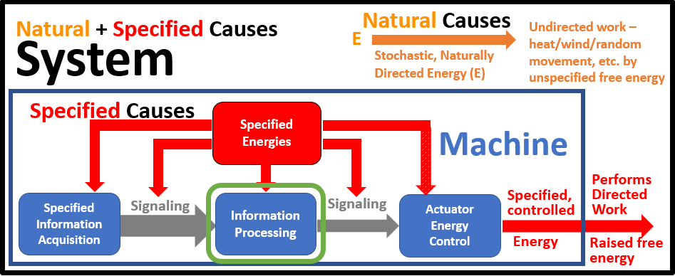
For a machine to achieve specified results, it must process the information it acquires to trigger the specified action. In other words, there must be something akin to what we engineers call a transfer function: an output that is a function of the input information. It may be digital, analog, logical, linear, non-linear, lookup tables, or neural networks.
Figure 5. The green circle highlights the information processing function discussed in this section.
Implementing an algorithm typically involves a multi-step process. The exception is a mousetrap or a light switch, a binary, single step of specified work, performing the information processing.
However, suppose a machine senses three information parameters, x, y, and z, and the transfer algorithm is (x + y) / z. First, the machine must compute x + y. Then, the machine must compute the result of that computation by dividing it by y. This algorithm has two process steps involving a new piece of temporary information, x + y. Logical and arithmetical process steps can be part of the algorithm. So, anything more complicated than a binary input-output requires multiple process steps, often with intermediate information. This fact has signaling coherence issues discussed in the signaling section. The problem is worse than described here for most complex algorithms. For this example, performing a digital multiplication or division requires many process steps in software or hardware (a hardware numerical processor added to a microprocessor).
The advent of microchip electronics and integrated computer chips has decreased size, cost, and increased speed, making many new applications feasible. Electronics have quickly become an integral part of mechanical machines, making them easier to use, less expensive, safer, and equipped with added features, while also improving performance and capabilities. Automobiles are a good example because most people are aware of the advances, as previously discussed.
The main reason these electronic machines make these capabilities possible is the inexpensive, high-speed microprocessors that can perform the complex algorithms processing real-time information fast enough for safe driving. Mechanical mechanisms could never accomplish these tasks, as electrons are orders of magnitude smaller and faster than mechanical parts.

Relationship Between Information and Intelligence, and Types and Levels of Intelligence
We humans use the term intelligence to mean several things. First, most use the term to describe our mind to think, create and use language, conceptualize, etc., which herein is called abstraction, meaning “the quality of dealing with ideas rather than events,” according to Oxford Languages We often associate intelligence with other animals, e.g., a dog is more intelligent than a cat.
We engineers also associate the term intelligence with computer functionality, which is the act of processing specified information under Machine Theory, which we call algorithmic intelligence and Webster calls computer intelligence. Algorithmic processing must first acquire the information it is processing. The processing may be mathematical, a lookup table, a logic diagram, or a neural network. Neural networks have the ability or characteristic to have preset (pre-learning), the ability to learn from experiences, forgetfulness, and remembrance after some time. Other hardware and algorithms can simulate neural networks.
There is a relationship between information and intelligence similar to a point to space. A point is not space, but space has no meaning without the concept of a point. Likewise, information is not intelligence, but intelligence has no meaning without the concept of information.
Abstraction does not involve processing designer-specified information; the process involves “thinking” about non-physical concepts such as language, theory, design, and mathematics. This process is not understood and lies outside the realm of Machine Theory.
We observe intelligence only in life and man-made machines. Therefore, we can conclude that machines link the realms of physics and intelligence except for abstraction. The “intelligence” of the information processor of the machine limits the sophistication of a machine’s work. For example, with their algorithmic information processing capability, we observe that cells can create specified molecules but cannot create anything living. With their neural network capability, animals can create non-living objects such as beehives and ant hills, but they cannot create machines. Humans, with their abstract intelligence, can create machines, but not life, nor machines with abstract intelligence. By extension, we can assume a much superior intelligence with incredible dexterity at the molecular level, and probably the atomic level created us.

Actuation
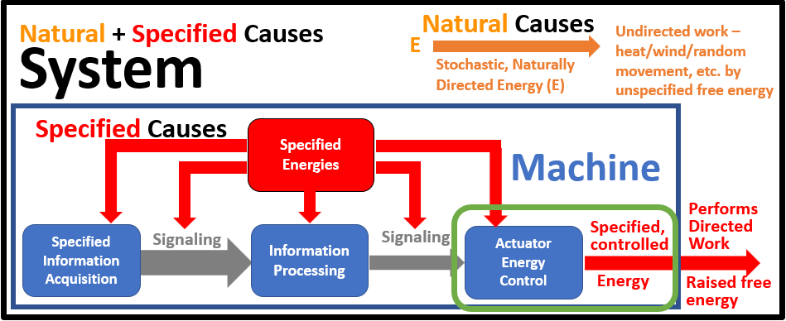
Once the signal processing determines the specified work of the machine, it signals a mechanism that controls the specified energy to force this work to occur. The term “actuator” was picked for this functionality as Webster’s definition is “a mechanical device for moving or controlling something.” Therefore, applying the term “actuator” to any mechanism that accomplishes this task, whether mechanical, electrical, chemical, magnetic, or fluidic, is reasonable. Stated differently, the purpose of the actuator function is to use the processed information signal to control the specified energy source to apply the exact amount of specified energy at the specified place, time, direction, etc., as needed to perform the specified work.
Figure 6. The green circle highlights the actuator function discussed in this section.
Often, the mechanism to accomplish the activation function is the hardest to design because a small incoming actuation signal may need to control an enormous energy, i.e., gain, as mentioned in the mousetrap (Figure 11) and the FM radio (Figure 14) examples. Using one energy type to control the specified energy of another type is a standard method to create a significant gain. For instance, a Caterpillar 992 front-end loading machine has a gain of 200 million between the force the operator applies to the joystick and the lift of the weight in the bucket. This gain is accomplished in two steps. The first step is to convert the voltage generated by the joystick circuit into a pulse-width modulated output (gain ~ 20,000), which drives a hydraulic solenoid to control the flow of hydraulic fluid from a hydraulic pump (gain ~ 10,000). This, in turn, moves the hydraulic cylinder that raises the load. This gain is an example of three energy type conversions: force to electrical energy to fluid flow, and fluid flow to force.

Specified Energy
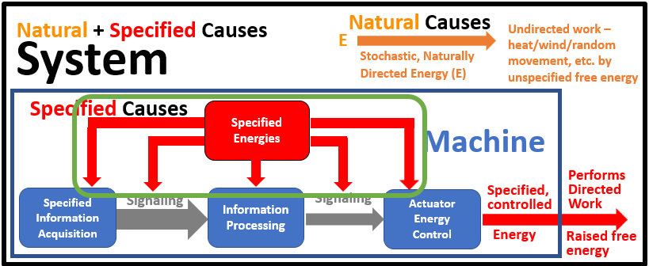
As stated earlier, specified energy powers two functions: 1) to perform the machine's functions and 2) to perform the specified work on the system. Each function might require a different energy source, some might share sources, or one source may work for all functions. Often, such as in the personal computer example in Figure 12, an external "universal" energy source, in this case, household AC power using AD/DC power converters, provides the specified energy for individual functions. Other components, such as the keyboard, might use a battery (chemical energy) as their energy source.
Figure 7. The green box highlights the specified energy required to achieve the machine function discussed in this section.
Energy requirements for machine functions are situational, and each energy source must be constrained to be released only when and where needed. For example, electrical energy is constrained by insulation, chemical energy by inert barriers, force energy by mechanical mechanisms, and magnetic energy by magnetic shielding, among others. These constraints are implemented by design, adding complexity, specificity, and lower entropy to the structure. Additionally, assembling the structure requires specific work.
Natural energy theory originates from chemistry, where heat is the most common form of energy. Chemical reactions occur when the random energy at some point in the chemical environment exceeds the activation energy required to initiate a reaction, and the Gibbs free energy is less than zero (ΔG < 0), which is the criterion for a spontaneous reaction. However, the same principle applies to other forms of energy, such as mechanical force moving an object, an electrical potential, or a changing magnetic field that causes a current flow.
Machines are not beakers of chemicals performing chemical reactions. Instead, they are collections of mechanisms, discrete parts that dynamically work together to perform work on the system in which the machine resides. The mechanisms in human-created machines are homogeneous macro parts assembled in a specified manner. Likewise, the mechanisms in life's cells are molecular "parts" assembled in a specified manner. The mechanisms in multicelled life organisms consist of assemblages of cells, but they all implement the same functionalities illustrated in Figure 2. The activation energy involved is the most significant difference between chemical reactions and mechanical and electrical work. We are all aware a threshold force must overcome what we call “stiction” before one can cause the motion of one object over another. Similarly, electrical current flows through a diode junction only after the voltage applied reaches the junction's threshold voltage.
As mentioned earlier, a specified amount of energy is required to perform the machine's functions. Natural causes cannot perform the simplest logic binary on/off since all natural processes are irreversible The machine functions often use a different energy source than the energy that performs the work on the system, as the needs are usually quite different, as was the case for the mousetrap, as shown in Figure 11.
Specified energy is confined to the machine, isolated from the system except at the "output" of the actuator, which modifies this energy source based on the processes information to be the precise energy in type, quantity, potential, location, and direction, etc., needed to perform the desired work on the system.
Specified energy is either generated by other machines (e.g., an engine), stored energy created by machine-created devices (e.g., battery, flywheel), or machine-created devices that convert natural energy to specified energy (e.g., solar cells or windmills). Therefore, it takes specified energy to create specified energy, another causal circularity.
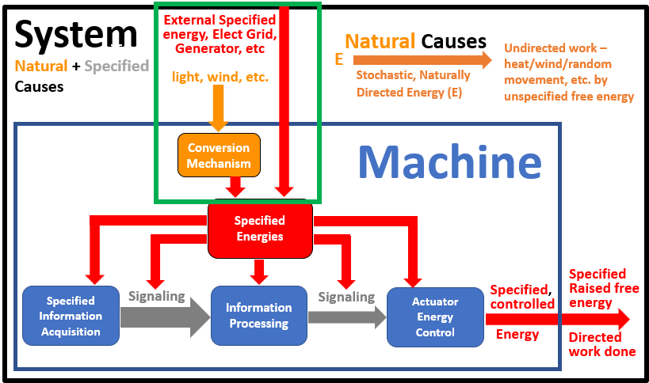
The machine's energy often comes from outside the machine or the system, shown as the red line coming into the system in Figure 8. The most common source is AC electrical power from afar, generated by hydroelectric dams, nuclear power generation plants, fossil fuel generation plants, or wind or solar farms. It is shown in red to indicate that it is already specified energy. Another local (within the system) method is to harness natural energy, such as wind, using a windmill (the orange components in Figure 8).
Figure 8. The green box shows energy sources that emanate outside the machine.

Signaling (Information Transfer)
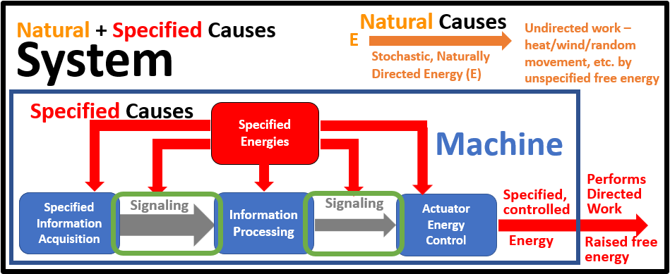
Signaling (synonymous with “information transfer”) between mechanisms must be “properly understood” on both ends of the transfer to be useful or coherent in engineering terms. Sometimes, the signal between functions is part of the design of one or both functions. This integration makes the signaling “invisible.” The mousetrap example illustrates this effect as described earlier.
Figure 9. The green circles are the signaling (information transfer) function discussed in this section.
Mirroring the mousetrap example, the information acquisition to processing function radio example has a combined mechanism, as shown in Figure 14.
An engine is another example of a machine with combined functions, where crankshaft rotation drives gears and pulleys, transferring the rotation angle to the push rods, rocker arms, valves, and valve springs. This work combines information sensing, signaling, and processing, as well as the signal to ignite the fuel, which is the actuation. In addition, the signaling function, combined with information acquisition and processing in the mechanism design, solves the coherence issue.
A machine called a UART, described in the Personal Computer section, page 19, converts serial data from a keyboard to parallel data used by the computer, as shown in Figure 12, to provide the hardware coherence needed. Vehicles and heavy equipment utilize serial databus technology, following standardized, layered protocols that define the various aspects required to achieve coherence. These protocols specify the hardware, data rates, packet sizes, headers, and footers that define the content, data structure, checksum information, and other relevant details. This same technology provides wired network connections (Ethernet, USB, HDMI, etc.) and wireless serial data transfer (Bluetooth, WiFi, etc.), with additional layers to account for the wireless aspects of the communication.
The cell phone is the ultimate information communications device, as described in the Cell Phone section, page 20, Figure 13.
Signaling is not limited to the transfer of information between functions. It also occurs within the machine functions, mainly the information processing function. As described in the Information processing section, processing algorithms transfer information from one process step to another. Therefore, information coherence is a design issue within one machine function (process information) in such machines.
Biological signaling also comes in many forms. For example, physical particles such as GTP-binding proteins are used in cells to transfer information physically. Nerve signaling is very similar to electronic signaling and works “globally” throughout the entire body of a living organism, much like data buses in vehicles.

Initial Conditions, Start Machine Process
Machines do not occur naturally. Engineers first design machines and then build them. But a machine isn’t performing intelligent work until its process is running. Starting a machine’s process involves setting initial conditions and performing a specified action (work) that starts the process. For example, some entity must set the time on a watch (set initial conditions) and wind it (start its process by providing its specified energy) before it keeps time. A human must bait and set the hammer of a mousetrap, and a mouse must touch the bait to start the process. A gas engine must have its ignition timing set, its fuel and water lines primed, and its battery charged before it can be started by cranking the engine. Performing initial conditions and starting a machine’s process is specified work that only an entity with machine functionality can perform: a causal circularity.
Some machines that run complicated processes have complicated initial conditions. The general-purpose computer and cell phones are examples where a controlled shutdown sets initial conditions for a safe startup. There are many other examples.
Starting the life process is many magnitudes more complex than any human-designed machine. The numerous simultaneous, interdependent functions contribute to this complexity. Life builds many of these machines on an as-needed basis. These factors mean that there is no fixed configuration as there is in human-designed machines. This problem has profound repercussions and is discussed more fully in the Life section following.

Machine Examples
A few machine examples are described in this section to establish the relationship between machine functions and the mechanisms that implement them.

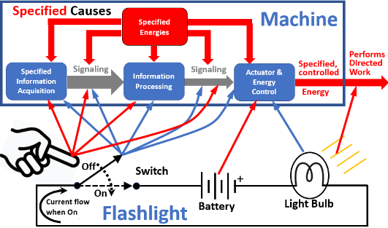
Least Complex Machine, Flashlight
Figure 10. Diagram of Flashligh Machine, illustrating relaationship of functions & energy sources to flashligh components.
Perhaps an incandescent flashlight is the simplest machine. It has only four parts: the On/Off switch, a battery, an incandescent light bulb, and wiring that connects these components. One mechanism, the switch, enables simplicity because it supplies both the energy and mechanism for the machine functions of acquiring the specified information, processing the information, signaling, and energy control, as shown in Figure 10. The information is “On” or “Off.” The information processing is “when the switch changes from 'Off' to 'ON,' closes the circuit, and vice versa to turn the light off. And the energy control mechanism is the switch physically closing the circuit.
As shown in Figure 10, the actuator mechanism is the light bulb. It changes the electrical current into light. And the energy delivered to the system is this light.
The Human operating the flashlight provides the specificity for the machine as it only operates when and where the Human specifies the action. The flashlight expands human capabilities by providing “night vision.” A tool like a screwdriver also expands a human's capability. However, it is a passive device that depends on humans for all the specified energy to perform the work on the system. The screwdriver lacks mechanisms for information acquisition and processing.
Therefore, a human using a flashlight or a screwdriver can be considered a new machine with enhanced capabilities. A Human and a flashlight are separate machines, but they can be considered one when used together.
One could argue that a switch performing most machine functions should not make it a machine. But Figure 10 shows that logically, the switch performs five functions: sensing intent, processing, actuation, and providing the energy to perform these functions. Additionally, the signaling functions are also embedded in the switch closure.
The purpose of including this machine example is to emphasize the need to consider machines as processes. The mechanisms are just the means to achieve the machine's functions. Often, mechanisms perform more than one of the functions involved. This flashlight example is possibly the most extreme example. It is the process that enables the conversion of an intelligent entity's intent into a specific task.
The flashlight example illustrates the machine's initial condition needs as well. If the flashlight uses rechargeable batteries, they must be charged. If non-rechargeable batteries are used, they must be replaced as needed. And the light needs to be initially set to the “off” position.

Simple Machine, Mousetrap Example
Figure 11 shows the mousetrap machine’s relationships between the functions (blue boxes and blue dashed lines) and the specified energies (red boxes and red dashed lines) to the mechanisms that implement these functions. The mousetrap is another example of a mechanism combining functions.
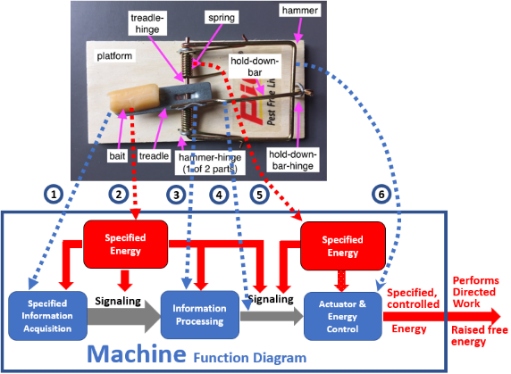
The bait (blue line 1) serves as the sensor (acquisition of specified information). The mouse moves the bait, which is attached to the treadle, signaling the mouse's presence by directly transferring the mouse's force (red line 2) to the treadle. The mouse’s force also provides the energy for signaling and information processing, as shown in Figure 11. The treadle processes the signal by moving, which, by design, releases the hold-down bar (blue line 3). The hold-down bar release is the information processing of the actuator signal (blue line 4). Upon release, the actuator, the hammer-spring combination (blue line 6), allows the specified energy stored in the spring (blue line 5) to slam the mouse with fatal force. A clever design accomplishes all this functionality with very few parts.
Figure 11, Mousetrap, parts labeled, and correlated to the machine functions with the blue dotted lines, except for the signaling functions.
Like the flashlight example, there are two sources of specified energy (mouse and spring) to add specificity compared to the generalized machine functionality diagram Figure 2. The difference between these forces also illustrates a characteristic needed in some machines, what engineers call "gain." Gain is the ratio of output to input energy, a measure of the ability of a small energy source to control a large energy output. In this case, the gain would equal the strike force of the hammer divided by the mouse's touch force.
The two energy sources also highlight that machine work is required to generate specified, raised energy. In this case, the mouse, alive with machine functionality, provides some of this energy. A human winds the spring in two stages: during manufacture and the trap set. Some machines' sole purpose is to generate specified energy,e.g., an engine. Batteries' sole purpose is to provide specified energy, but they are not machines. However, machines had to produce them. The fact that machines require specified energy and only machines (humans with machine functionality) can create it is a causal circularity.
The mousetrap example illustrates other characteristics of machines as well. For example, machines require intelligent work to set initial conditions, namely baiting and setting the trap. In addition, machines have components held "away from equilibrium," exemplified by the wound-up spring, held in place by the tenuous treadle hold-down bar configuration, plus the additional spring wind supplied during manufacture to provide hammer force on the mouse once struck. As a result of the tenuous stability, a "stomp on the floor" vibration will likely exceed the activation energy level necessary to activate the mousetrap and short-circuit the information acquisition, signaling, and information processing function provided by the touch of the mouse. Furthermore, such tenuous stability in machines tends to decay over time, making evolution impossible.

Personal Computer: Example of a Machine
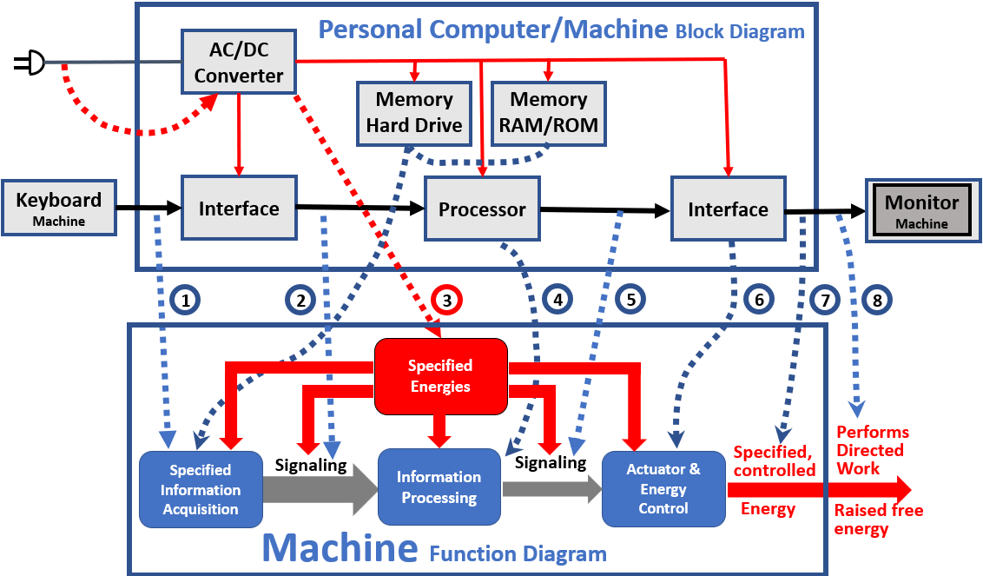
Unlike the mousetrap machine example, a personal computer uses separate mechanisms to perform all of its functionality. By contrast, most machines combine functions in mechanisms, blurring the distinction between functions and mechanisms, making a computer an excellent illustration of aligning mechanisms with functions. Additionally, most people use computers and have some understanding of what is inside them.
Figure 12. Shown is a simplified block diagram of a Personal Computer, and relating the functions of these blocks to the Machine Function diagram used herein to explain the functions necessary to perform Specified Work. The dotted blue lines connect the mechanism
The dotted lines in Figure 12 show the relationship of the computer parts to the machine functions they perform. For example, a modern keyboard is a machine that usually uses a battery as its specified energy source and a microcomputer to decipher the keystrokes. It then conveys the keystrokes to the computer, usually by a wired or wireless USB (Universal Serial Bus) or Bluetooth wireless serial data bus.
Once inside the computer, the Interface block (Figure 12) converts the USB serial data stream to parallel data the processor needs. A device (a machine) called a UART (Universal Asynchronous Receiver-Transmitter) accomplishes this task. This "signaling" provides data coherence between the keyboard and the computer, as illustrated by a dotted blue line in Figure 12.
The processor, typically an integrated semiconductor circuit, comprises sub-machines that execute the process steps specified by the software in memory, along with keyboard input.
Another UART Interface is needed to communicate the display information in a form that provides the signaling coherence required. The display content is the specified work of the computer/machine, as illustrated in Figure 12. The processor may also store specified information for future use in memory and perform specified work. The monitor, also a machine, converts the specified information from the computer to specified images on the CRT.
The AC grid power enters the computer AC to DC Converter block in Figure 12 and converts the AC to the specified energy needed by all the computer's functional blocks. The AC to DC converter typically is a machine that uses feedback control to provide the precise voltages and currents required by the mechanisms in the computer and to supply power to the computer for a while after power loss to allow shutdown software to turn off safely and set the initial conditions for the next power up. Such power is entirely foreign to the natural world.
As these examples show, humans sometimes perform the set initial conditions work (e.g., a mousetrap); in other cases, the machine performs these functions (e.g., a computer). Also, the need to set initial conditions only occurs on initial startup for some machines that involve human input, such as the room light circuit example, where a human provides the specified input information and the raised energy to operate the switch. Or the windmill example (Figure 15), where natural energy starts and stops the machine process.
Humans design machines to fulfill human desires and needs, and interact with them by providing specified input information during operation, design, or both. Therefore, one could say the Human becomes part of the machine.

Cell Phone, the Ultimate “Information Machine”
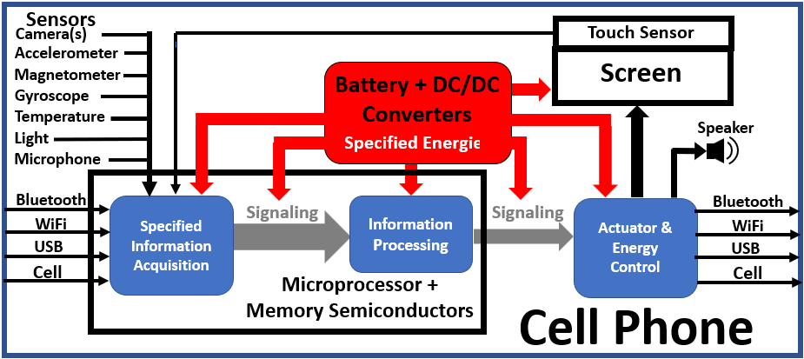
The cell phone, shown as a hybrid mix of functionality and mechanism in Figure 13, epitomizes this revolution and merits discussion as it is an “information-in, information-out” device. Each application makes the phone a different machine. The key to making the cell phone possible is the ability to gather, process, and convey information. It obtains information initially through the setup process that installs the operating system software and applications needed to operate the cell phone, as well as those chosen by the supplier. Then, the user can install additional applications to suit their needs and desires. There are an estimated 9 million cell phone applications as of the time this is being written.
Figure 13. Cell Phone functionality block diagram showing sources of.information, target specified work devices, and specified energy.
The applications take advantage of the additional information the phone can obtain and share from four separate information-sharing wired and wireless technologies. They include cellular, USB (Universal Serial Bus), WiFi (Wireless network), and Bluetooth. These data buses both receive and send information to and from the cell phone, sharing the same hardware shown on the left and right sides of Figure 13. The arrows, from left to right, represent the flow of information in various forms and content.
A cell phone is a device designed to process and transmit information. However, it can be the device that controls other machines, which perform specified work, thereby becoming part of a higher-level machine. An example is using a cell phone to control a robotic vacuum cleaner. The cell phone controls the vacuum cleaner’s movements. The vacuum cleaner includes proximity sensors and actuators that control its movement. Initially, it conveys its movement details, where it hits obstacles, allowing the cell phone vacuum cleaner software to create a floor plan. The owner can then assign room names and program cleaning times, among other tasks. This robotic application is highly sophisticated and incorporates numerous technologies. Naturally, engineers take pride in such accomplishments. But compared to living organisms, this accomplishment is insignificant.
The cell phone is an excellent example of a many-layered machine. Each of the sensors inside the cell phone is a machine. Each has a mechanism to sense the parameter(s) involved. Electronics convert each sensor’s data into the format required by the cell phone’s Central Processing Unit (CPU), which then processes the information according to the application’s specifications. The CPU semiconductor is an assembly of sub-level machines that perform numerical processing, move information to and from storage areas, manage tasks, and create a pacing clock signal, among other functions. In addition, the CPU semiconductor often contains mechanisms that are part of other machines, such as sensor machines. Factors such as manufacturability, technological limitations, and reliability drive design considerations, not the boundaries of machine functionality.

Simple Semiconductor FM Radio
Figure 14 is a circuit diagram of possibly the most used example of a simple powered semiconductor radio that electronics schools use as a teaching aid. A radio is a machine, so each function is outlined in a different color. The function of the radio is to convert the electromagnetic signal from an FM radio station into audio. The information acquisition is the antenna and transistor T1 in the blue box. The components in the green box carry out the information processing function, which converts radio frequency information into audio frequency information. The components in the orange box perform the actuator function by converting the audio frequency signal into sound. Finally, the red box indicates the specified energy for all these functions, which consists of a battery with a voltage-stabilizing capacitor.
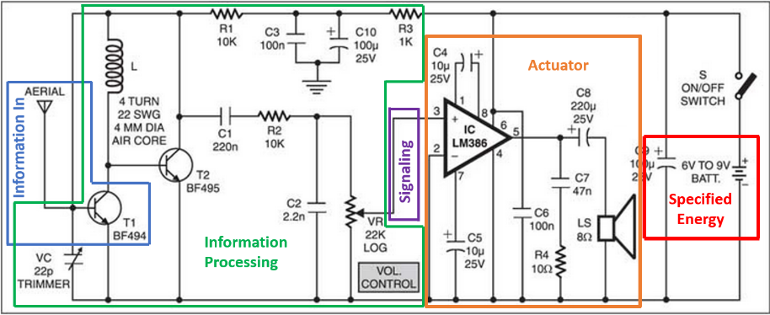
The actuator’s main functional parts are the LM386 operational amplifier (OpAmp) and the speaker. The LM386 is an operational amplifier specifically designed for this type of application. The targeted functionality of the LM386 OpAmp eliminates the need for many additional parts compared to using a general-purpose OpAmp. For example, it features a ground-referenced input and a mid-point output reference. It has a high current output capability to drive high current loads, such as a speaker or solenoid.
Figure 14. Circuit Diagram of a simple FM Radio. Color-coded boxes surround the Machine Theory functionalities. Image courtesy of electronicsforu.com
The signaling between the information acquisition and information processing functions is embedded in the overlap of these two functions and, therefore, does not require any additional mechanism. The wire that connects the volume control variable resistor and pin 3 of the OpAmp IC, as shown in Figure 14, performs the signaling between the information processing and actuation functions.
This example illustrates several characteristics inherent in most actuators. The first is gain, previously mentioned. Gain is needed to limit the amount of specified energy required to operate the machine and to avoid the additional complexity, heat, size, and cost of using a lower gain. For example, the energy gain from IC pins 3 to 5 is 40,000, made possible by the field-effect IC technology implemented through good design.
Hydraulic and gas valves are other high-gain examples used in machines. In them, a relatively small force applied to their valve control mechanisms (which come in many types) can create a significant pressure (and, therefore, flow) change.
The second characteristic is the frequent use of various energy-type transitions in a machine to achieve the specified result. In the case of the radio, Figure 14, energy transitions include chemical to electrical (battery), electromagnetic radiation to electrical (RF sensor), electronics that use numerous mechanisms that convert between voltages and currents, and electrical and magnetic fields using various static and active devices. Finally, the speaker uses a current-generated magnetic field conversion to create a physical force that produces the sound. One rarely sees so many different energy types in a natural system, and never used to create specified work except when the system includes a machine.
These achievements are made possible by an educated and organized society. First, we conceive, create, and design things. Then we obtain and process raw materials from all over the world. Then create specialized parts and materials and transport them to manufacturing facilities. Finally, we manufacture machines that make our lives easier, safer, and more fulfilling. All this involves trillions of specified process steps. And natural causes cannot execute a single one of them.

Windmill
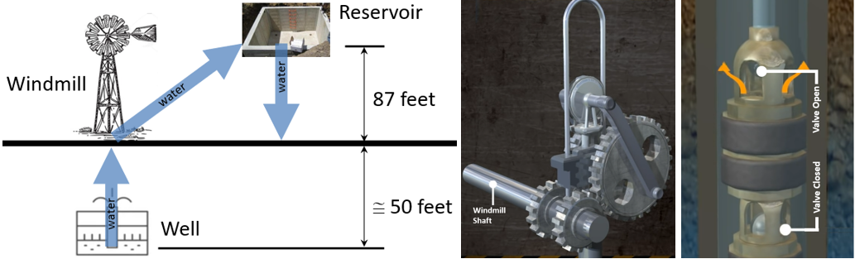
The definition of a machine is a device or system that performs specified work. One might question how the windmill that pumps water to an elevated well, as shown in Figure 15, could be called a machine that doesn’t work when the wind is not blowing. The answer is to add “when the wind is blowing” to the specification.
Figure 15. Windmill Pump Machine at farm author’s youth. A windmill-driven water pump from a well to a reservoir as shown on the right. In the center is the mechanism that converts the windmill rotary motion to vertical up/down motion, and to the right is the piston pump at the end of the down stroke position. Courtesy of Wind Turbine Systems Private Ltd., see their excellent explanation video at: https://www.youtube.com/watch?v=BugXmDxC0WM
The windmill uses the mechanism shown in the center of Figure 15 that converts the rotary motion of the windmill blades into vertical, up-and-down motion. The force transferred by the mechanism is the specified energy. The specified information is whether the piston is moving up or down, as well as its high and low points. Information processing involves the opening and closing of valves at the high and low points. The actuator is the piston, which undergoes up-and-down motion, and the pressure-operated valves control the “pulling” of water up and the “filling the bucket” on the down stroke.

Life

Definition of Life
There is no standard definition of life. Webster's definition is: "the ability to grow, change, etc., that separates plants and animals from things like water or rocks." Biology textbooks typically use a page or two to provide definitions that summarize the characteristics and functions of life.
Victor and George Tetz posited this definition: "Life is an organized matter that provides genetic information metabolism," with the phrase "genetic information metabolism meaning to comprise functioning, reproduction, and creation of genes and their distribution among the living and non-living carriers of genetic information."
The Oxford Dictionary definition: “the ability to breathe, grow, reproduce, etc., that people, animals, and plants have before they die.”
A definition of life emanating from machine theory is: "Life is a continuous process conducted by machines that enables metabolism, development, adaptation, propagation, and performance of specified work on its environment."

Life Machine – Flagellum
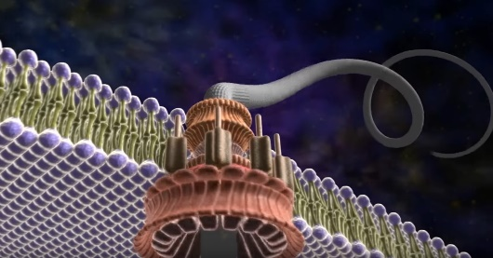
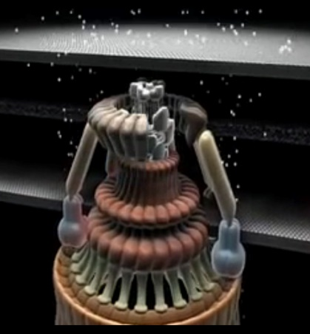
A flagellum, shown in Figure 16, is an example of a biological machine because it is one of the most studied life machines. Also, the actuator (motor) resembles a human-designed motor. And the mechanisms neatly align with the machine functions, as shown in Figure 2.
Figure 16. Constructed image of a flagellum.
Figure 17. Illustration of proton flow between membranes that creates the specified energy for the flagellum.
Figure 17 is an artist's rendition of proton (H⁺) flow (the white dots) moving between the cell wall's external and internal membranes that provide the raised energy powering the rotation of the flagellum.
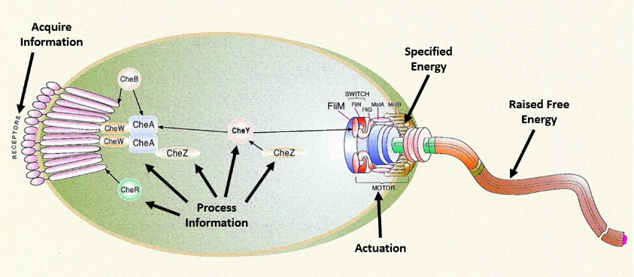
Figure 18 shows the mechanisms that control the flagellum's operation. The information sensors are the "receptors" shown on the left side of the figure. In this case, they are "chemoreceptors," proteins that detect and follow chemical gradients over a wide dynamic range outside the cell's wall, providing the cell with the information needed to find food and avoid danger. The Che(X) molecules (center of Figure 18) process this information, which then signals the Fli(X) molecules (right of Figure 18) to control the flagellum motor. This simplified description identifies some of the functional mechanisms of the flagellum machine, which conforms with the posited machine theory.
Figure 18. A drqwing that illustrates the mechanisms that control the flagellum's operation.

A Machine Theory's Impact on Life's Design
Machine theory identifies the need to perform several levels of intelligent work. As discussed in the mousetrap example, one must acquire the materials, make the piece parts, assemble them with a partially wound-up spring and bait, and set a mousetrap. Similarly, after building an engine, one must charge the battery, fill fluids, prime the fluid lines, and then crank the engine to start it.
Imagine the difficulty of building a cell and "cranking" it to "start" its life process. Life is much different from human-designed machines. Life forms are a continuous process. Once, for example, the life process of the first E. coli bacteria cell was initiated, it probably took about 20 minutes for it to start dividing (mitosis), thereby avoiding restarting. Instead, it divides both the process and matter. There is no mother and daughter; there are two mothers. So, the original life process becomes two physical processes, but it remains the original process. So, one can accurately say that all E. coli bacteria that exist at any time represent the living E. coli process. Suppose something changes the process in a particular E. coli bacterium over time. In that case, there will be a new strain of that process, but they all have the same "mother," and the living bacteria are the current state of the process at any given time.
Machine theory applied to life anticipates cell division instead of reproduction because of the intelligent work external to a life form that is required to start the life process. Cell division avoids such external involvement. This realization also highlights the necessity of creating mothers for all the life forms that exist. This topic is not discussed further in this context.
For argument's sake, let us assume that the five differences between life and human-created machines in the previous section make assembling and starting the life process an order of magnitude more complex than assembling and starting a human-machine running process. That would mean starting life is 100,000 times harder than starting a human-designed machine. Importantly, this assessment does not include the design challenge. Our brain is too weak, and our fingers are too large to create life.
Another way to think about the problem of assembly, plus starting the machine or life process, is through the lens of causal circularities. For example, ATP is a prerequisite to creating additional ATP. Every causal loop must be broken by "hand assembly," while other parts of the causal loop are held in a state of non-equilibrium until the cell begins to "live." Only at that picosecond can additional molecules be created to perpetuate the biological process. And there are hundreds, if not thousands, of such causal circularities in the cell.
So, machine theory reinforces the necessity of cell division compared to cell creation and why all living biological organisms must start as a single cell. Future machine theory will elaborate on the use of cells as life's building blocks.

A Design Engineering, Machine Process-Driven Perspective of Life
The author of this paper is a machine design engineer with little biological background. However, engineers and biologists identify the life machines' functionalities, i.e., information gathering, processing, and controlling specified energy, although they lack a complete understanding of most of the machines' mechanisms. Life's machines are orders of magnitude more complex due to their necessity for perpetual self-sustainability. Also, the building blocks of life mechanisms (cells) are molecular in scale compared to macro-scale human-designed machines, making it impossible to observe their structure and operation directly. For these reasons, we will likely never fully understand all the machines in life.
Despite these obstacles, biologists have learned an incredible baseline of information regarding the functioning of life. Biologists can almost always identify the information, information processing, and the specified energy used by life’s machinery. Natural, “downhill” chemistry accounts for many of the process steps in life. However, life’s machinery establishes the initial conditions for this chemistry.
The textbook "Biochemistry, The Molecular Basis of Life" gives this description of life machines:
"Researchers now recognize that many of the multisubunit complexes involved in cellular processes function as molecular machines: physical entities with moving parts that perform work, the product of force and distance. Like the mechanical devices used by humans, molecular machines ensure that precisely the correct amount of applied force results in the appropriate amount and direction of movement required for a specific task to be completed. Machines permit the accomplishment of tasks that often would be impossible without them.
Although biological machines are composed of relatively fragile molecules (primarily proteins) that cannot withstand the physical conditions (e.g., heat and friction) associated with human-made machines, the two device classes share essential features. In addition to being composed of moving parts, both require energy-transducing mechanisms: they convert energy into directed motion. Despite the vast diversity of types of work performed by biological machines, they all share one key feature: energy-driven changes in the three-dimensional shapes of proteins. One or more components of biological machines bind nucleotide molecules such as ATP or GTP (guanosine triphosphate). The binding of nucleotide molecules to these protein subunits referred to as motor proteins, and the release of energy that occurs when the nucleotide is hydrolyzed, results in a precisely targeted change in the subunit's shape.This wave of change is transmitted to nearby subunits in a process that resembles a series of dominoes falling. Biological machines are relatively efficient because the hydrolysis of nucleotides is essentially irreversible: therefore, the functional changes that occur in each machine occur in one direction only."
Signal transduction in organisms is the heart of much of the machinery. Here is the description of the process from the same textbook:
"If energy is the force that drives biochemical processes, then information is the power to specify what is done. Self-organizing living organisms are so complicated that they must have not only precise structural specifications for each type of biomolecule, but also specifications for how, when and where each type is to be synthesized, utilized, and degraded. In other words, living organisms require both energy and information to create order. Survival requires that organisms process information from their environment. For example, bacterial cells track down food molecules, plants adapt to changing light levels, and animals seek to avoid predators. Information, or signals, come in the form of molecules (e.g., nutrients) or physical stimuli (e.g., light). Although organisms are bombarded with signals, they can adapt to changing environmental conditions only if they can recognize, interpret, and respond to each type of message. The process that organisms use to receive and interpret information is referred to as signal transduction. Although both prokaryotes and eukaryotes process environmental information, most research efforts have been concerned with eukaryotic signal transduction. Consequently, the following discussion focuses on information processing in eukaryotes. Examples of eukaryotic signal molecules include neurotransmitters (products of neurons); hormones (products of epithelial cells), and cytokines (products of white blood cells). All information-processing mechanisms can be divided into four phases:
- Reception. A signal molecule called a ligand, binds to and activates a receptor.
- Transduction. Ligand binding triggers a change in the three-dimensional structure of the receptor that results in the conversion of a primary message or signal to a secondary message, often across a membrane barrier.
- Response. Once initiated, the internal signal causes a signaling cascade, a series of reactions that involve covalent modifications (e.g., phosphorylation) of intracellular proteins. Results of this process include changes in enzyme activities and/or gene expression, cytoskeletal rearrangements, cell movement, or cell cycle progression (e.g., cell growth or division).
- Termination. The efficiency and effectiveness of signal mechanisms requires that they be terminated in a timely manner. Living organisms use a variety of signal termination methods. For example, signaling molecules may be destroyed or removed (e.g., neurotransmitters such as acetylcholine modification (e.g., removal of phosphate groups), and nonprotein signals are degraded by enzymes.
These quotes from a textbook recommended by a college biology professor proclaim that life machines are the molecular equivalent of human-designed macro machines. They require the same functionalities: acquiring and processing specified information, and using the result to control the energy (ATP) required to perform specified work. However, human machines aren’t “built when needed.”
The signal transduction narrative suggests that the mechanisms involved combine signaling, signal processing, and actuation functions. The termination illustrates another reason life is much more complicated than human-designed machines. Life builds many machines when needed, then recycles them after they have completed their task. The termination step is needed for the life process to initiate the recycling process. Human-designed machines cannot rebuild themselves.
Virtually all OoL abiogenesis and ID arguments address the ability of natural causes to create the physical structure and provide the energy required for life. However, in the author's opinion, neither adequately addresses the intelligent work necessary to start the life process.
As someone whose career involved designing machines, I cannot conceive of a method to initiate the life process. There are numerous causal circularities. One is ATP, an unstable molecule that does not exist naturally on Earth. Yet, most machines in a cell use ATP as their energy source. A machine called ATP synthase produces ATP and utilizes it in the process. How does one "seed" ATP in a cell structure to start the ATP synthase machines? These causal circularities render the possibility of creating or restarting natural life impossible during living cell reproduction.
Since the cell can repair itself and build and recycle machines as needed, it can duplicate and divide its structure and running machinery in one continuous, complicated process, it eliminating the need to restart the life process, which seems impossible to me.
When designing machines, engineers start with a specification. Then, one develops a design concept based on one's "toolkit" of capabilities: the technology that the designer knows how to use. The designer must invent mechanisms that fill the gaps if such a solution does not exist.
Once a design is complete, a designer knows exactly how the machine works, can make measurements anywhere in the functioning machine, and can correlate and explain them. Another engineer with comparable skills and background can usually reverse-engineer the machine and build their own.
One can compare the ability of engineers to reverse their machine creations to biologists' ability to reverse engineer the inter-workings of life by comparing a computer IC (Integrated Circuit) to a cell. The smallest logic gate theoretically feasible is approximately 10 nm in length and width, which is approximately twice the size of a large prokaryotic cell or a small eukaryotic cell. There are over a billion logic gates in the typical PC's "information processing" module, making this functionality alone about a billion times the size of a cell. These logic gates do not include mechanisms to produce the specified energy, acquire the specified information, or all the actuators needed for all the machinery in a cell, nor the enclosure. Cells possess capabilities far beyond those of any man-created machine. These include finding, capturing, and metabolizing food, adapting to its environment, repairing itself, warding off attacks by viruses, and dividing itself into two separate cells without disrupting the life process it is running.
High-performance computers typically consume about 300 watts compared to a cell's 3x10⁻¹⁰ watts. This approximation makes the cell a trillion times more energy-efficient than a human PC, enabling it to achieve unmeasurable, more intelligent work.
However, a computer is orders of magnitude faster than biology. I'm comparing a processor vs. a cell, not a brain. A brain using neural networks is 10 million times slower than a computer. The cell conducts many processes in parallel using multiple machines, so I am unsure how to make a comparable estimate.

Life and life's machines vs. Human-designed Machines
Every living entity is a machine because it performs specified work using the machine functionalities identified herein. But life is much more than a human-designed machine, so calling life a mere machine is a mammoth understatement. So, as previously suggested, instead of calling life machines, we can call life lachines to emphasize this point.
Our personal experience suggests that machines of a given intelligence level can produce entities of a lower intelligence level in a circular causation conundrum, implying that intelligence is the primal realm. The laws of physics and the details of the universe suggest that superior intelligence and physical dexterity at all scales of space and time are responsible for our existence.
Reverse engineering biological machines and processes is significantly more challenging than reverse engineering human machines. Here are some reasons.
- Size/scale: Human devices are orders of magnitude larger than cells. The smallest component of a miniaturized computer chip is approximately the same size as a whole cell, containing all the necessary machinery inside. This allows an engineer to connect instrumentation to the machine mechanisms and see and measure what is happening while the machine is running. One must use a super-expensive, high-technology light microscope to see a cell, and an electron microscope or X-ray lithography to see inside a cell. These technologies require the precise and stable mounting of a small specimen. The electron microscope and X-ray lithography are only applicable to non-living tissue.
- Time Scale: Since the distances that mechanism components must move to accomplish work in a cell are significantly shorter than those in human machines, they use orders of magnitude less time than their macro counterparts.
- The magnitude of signals: Cells utilize electrical signaling and control to regulate body growth, repair, and regeneration. The flow of ions creates the current flow that is a mechanism for these (at least the repair) actions. However, one can hardly measure these currents since the current density and speed are lower than the electron flow.
- Engineers know from the start how their machines work; biologists do not. Therefore, engineers can instrument their creations at any point and know what the result should be. For example, they know if the measurand is specified information needed for machine operation, a signal between information handling functions, processed information used to control an actuator, or other incidental information that is an artifact of the mechanisms involved. Unfortunately, the same is not true in the cell. As a result, biologists acquire information with incredible difficulty. When biologists can acquire information, they may not know whether it is specified information, processed information, signaling, or incidental mechanism information.
- Design sophistication: The designer of life is orders of magnitude more intelligent than humans. Humans may not understand all the science involved in life or the sophistication of algorithms.
Human engineers can identify the available information and see the processing results of human-designed machines. Unfortunately, reverse engineering life is orders of magnitude more complex. Molecular-sized machines perform the work. The instrumentation used by human-designed machines to acquire information, at worst, stops the life process or, at best, alters the information. Our fingers are too big and slow, and we cannot see what is happening in the cell. X-ray diffraction revealed the structure of DNA, but it can only give us snapshots of an ever-changing target.
Despite the limitations and difficulties, biologists have made significant advances in understanding life, particularly at the highest levels. However, learning all the details of all the machinery involved may be impossible due to the obstacles listed.
Understanding machine theory can help biologists. Information is used to direct the work to be performed, for signaling, for processing, and for controlling the energy that performs the specified work. One can observe information everywhere in life in the form of shapes, molecular structures, movements, ion flows, voltage potentials, and other phenomena, to name a few. But what is the function of any observed information? Understanding MT can help.

Conclusions
Machine Theory clarifies the differences between natural systems and those that include machines. To wit:
- Machines are the only physical method of performing work on the system they occupy, which is determined by the mind, as opposed to natural causes. Natural causes may be able to perform the same work as a machine, but not with the same level of designer specificity. For example, weather, driven by the sun’s energy, can raise water from a lower level to a higher level or sprinkle water on a field. But unlike a machine, weather cannot maintain a lake at a specified height or sprinkle water at a specified amount and schedule.
- The machine theory presented here provides the insight needed to clarify ambiguities in the definitions of machines, information, intelligence, and life, and to distinguish between natural vs. specified causes, work, processes, energy, and determinism. These clarifications should lead to more precise definitions and less confusion caused by the current overlapping terminology.
- It adds to and strengthens the Intelligent Design (ID) arguments by removing, with specificity, the idea of a finite probability of the Origin of Life (OoL) being caused by natural causes and by providing a simple method to falsify this theory if it is false. Machine Theory suggests that the hurdle for a natural OoL is not creating a particular state of matter or energy (an information token) but rather creating an intelligent process (gathering and processing specified information, i.e., intelligence), a much higher hurdle as explained herein.
- Machine Theory identifies the dividing line between specified work based on algorithmically processed information, as opposed to abstraction. Unlike machines, the starting point of abstraction is not the acquisition of information specified by designers. Also, abstraction is strictly “mind” work; it does not directly perform work on the system. These are two separate forms of intelligence. Abstraction must precede algorithmic work. Therefore, machines cannot abstract; we do not understand the process(es) or mechanisms. Machines are the only manifestations of intelligently performing work on a system we observe.
- Machine Theory highlights the other aspects of creation that are important to understanding life and human-created machines. Not only must a design for a machine be conceived (abstract intelligence), but the design must be created (algorithmic intelligence). Creation involves numerous process steps that are specified work, a causal circularity. Natural causes cannot perform specified work and, therefore, cannot create machines; there is zero probability for natural causes to create machines.
- Machine Theory identifies the process that creates specified results, not the mechanisms. Many designs might meet the goals of a given application. Still, the laws of physics, the matter and energy resources available, and the designer's ingenuity and physical dexterity in manipulating these resources set initial conditions and initiate the machine’s process, limiting the creator’s choices. These limitations dictate design decisions, and in the case of life, explain why the cell is the building block of life and that all multicellular life forms start as a single cell created through cell division.
- Probability calculations for the occurrence of a machine by natural causes do not apply because a machine is not a static thing but a running process. There is no “fixed state” that defines a machine. The running process is required to maintain the “away from equilibrium” status a machine requires to perform work that natural causes are incapable of.
- Machine theory cannot be reduced to laws of physics alone; instead, the designer implements the machine process by creating an intelligent arrangement of matter and energy that performs the work dictated by the designer’s specifications. The design involves specified information, including the state variables that dictate the performance of the specified work (Maxwell Information?), which necessarily includes the time and place the specification applies because all machine process steps must apply to the system it interacts with. The process steps constitute intelligent action that performs specified work (Maxwell Work) within the machine system, which is impossible through unspecified natural causes acting alone. The machine’s internal workings and operation on the system depend on specificity, not probability. The designer performs probability calculations to compute the probability that the machines’ process steps will NOT be successful. Machines are added to a system to eliminate the dependence on a positive probability that natural causes could accomplish a specified task. In a sense, all machine process steps are “natural” because they do not violate the laws of physics. They are “unnatural” because of the machine design, which includes “unnatural” specified, raised energy in a designed, protected manner that the machine “modulates” to the system as needed to perform the “unnatural” work made possible by the intelligent design and creation of machines.
- By machine theory's definition (an entity that performs specified work), all life forms are machines, but they are much more and deserve a different name (Lachines?). Lachines must be able to propagate, obtain their energy (food), adapt, repair themselves, and so on. These requirements make them orders of magnitude more complex than human-designed machines (HDM).
  - For Lachines to be the same order of magnitude size as HDMs, they must be molecular mechanisms instead of homogeneous structure mechanisms.
  - To limit size and be efficient enough to propagate and survive, they must build and disassemble some of their machinery as needed. This constraint means that there is no static “design” of a Lachine. One cannot create documentation that shows the exact structure of a Lachine. Lachines are constantly changing themselves as opposed to static HDM.
  - These differences between humans and life machines mean cellular actions occur much faster in cells than in HDMs. This difference between HDM and life, as well as Lachine’s molecular size, makes human observation of Lachines difficult to the edge of theoretical limitations.
  - However, life is studied more than any other topic, and biologists have learned much, even if the knowledge gained is only a tiny fraction of the total, including:
    - DNA is the “library” of specified information that provides the blueprints for protein molecules, process instructions, information processing algorithms, etc. But there is much information we have not been able to identify, such as body plans.
    - The molecular machinery performs various functions, including converting DNA information into proteins, structures, and energy, as well as producing machine parts and instructions.
    - We can observe machines in action performing their functions and, in some cases, identify the specified information and mechanisms that process the information, actuate the necessary actions, and produce the energy used, even though we do not precisely understand how all these mechanisms work.
    - The macrostructures of multicelled life are studied and understood at a somewhat higher level.
    - We can surmise that life reproduces through cell division because it is much easier to duplicate an existing, running process than to start a new one. This hurdle is orders of magnitude greater for life than for HDMs due to its dynamic configuration. For example, how does one fix a “broken” protein molecule that fails during startup?
    - For multicelled Lachines, it is much easier to propagate with diversity by creating a new single cell that grows and develops through a cell division with a diversification process rather than creating a newly grown “tweaked” Lachine.
Ultimately, this theory is fundamental to understanding life and human-made machines, and it should be part of the curricula for engineers and biologists.
Machine theory provides the blueprint for achieving specified work; in other words, it provides the connection between the material world and the world of the mind, except for abstraction.
Machine theory enhances and clarifies the current ID arguments. Take Richard Dawkins's “The Blind Watchmaker” as an example. Let us grant that the blind watchmaker somehow built a trillion watches and placed them in every conceivable location on Earth to experience every possible natural situation. Would a single watch get wound? No. Natural causes lack the guided energy or information processing mechanism to perform specified work. Would a single watch get its time set correctly? No, natural causes are mindless with no concept of time. ID proponents don’t need natural causes to construct a watch to validate their point. Any example of Natural causes performing specified work, like winding or setting the time of a watch, falsifies the theory. A football analogy is that instead of letting opponents start their offense on the 25-yard line, we let them start on the 99.999-yard line, and they still can’t score.
Machine theory eliminates the probability arguments because the probability of Natural Causes performing specified (machine) work is absolute zero. Only the machine process can produce specified results. Only a machine of higher intelligence can create a machine of lower intelligence. Intelligence reigns over physics. One can easily disprove this theory with a simple example of natural causes performing specified work, such as the example of a watch. If challenged, an abiogenesis proponent can never provide an example. Unless and until this theory is disproven, Machine Theory should be the final nail that seals the abiogenesis coffin.
This theory offers a distinct perspective on thinking and analyzing work and creation. Instead of systems and structures, this theory focuses on processes and functions. Instead of considering the potential of natural causes to accomplish great things, the focus is on their ability to perform the most basic, simple tasks. Instead of a defensive posture of explaining why their big ideas are wrong, we can take an offensive stance of challenging abiogenesists to demonstrate any simple specified action. Of course, both approaches are valid and needed. However, machine theory identifies exact requirements to perform specified, aka intelligent work. There is no ambiguity.
Specific (intelligent) work is required to perform specified tasks on a system and to conceive, design, gather, and process the raw materials needed, assemble, set initial conditions, and initiate the machine's process. This fact poses numerous causal circularities. This hurdle is many orders of magnitude greater for life, an entity that can gather random energy and convert it to a form it can use to sustain itself and propagate.
Machine theory provides a roadmap for refining the definitions of life, machines, intelligence levels, natural versus intelligent causes, work, creation, and reality. There are only two creation pathways that are easily distinguishable.
This theory identifies numerous causal circularities, including the most fundamental: creating a machine takes a machine. A creation agent that supersedes all human theories is the only explanation for the existence of life.
In addition, Machine Theory sharpens the dividing line between things we understand and those we do not. According to the theory, an entity of a higher level of intelligence than our own must have created us by methods, physics, etc., that we do not understand.
At this point, Machine Theory is a theory that physicists, engineers, and biologists need to challenge. Like the 2nd law of thermodynamics, the theory should be easy to disprove if it is false. It is said about the 2nd law, “…it occupies the distinction of being one of the most useful and most general laws of all science.” Is it possible that the same could one day hold a similar standing, with the addition of the words “and philosophy?”
Finally, can Machine Theory explain other mysteries besetting humanity? For instance, do subatomic machines exist that perform such miracles as controlling the growth of bodies? Or cosmic-level machines that explain the mystery of dark matter and energy? Since the Big Bang, why should the hand of supreme intelligence be limited to life on Earth? Yet, on the other hand, perhaps machinery such as this far-out thought was necessary for our life to exist.

Many machines perform work that is possible by natural causes but cannot perform the work at a specified time and place. All machines run a process that requires numerous state changes that must occur in a specified manner including time and place.
“Extrinsically raised energy” means energy by the machine that does not otherwise exist in the system in the type, potential or amount at the location the specified work is to occur. This energy, when applied by the machine, therefore has the ability to cause an “unnatural” state change, such as to raise an object against gravity. In addition, raised energy performs the machine functions of acquiring and processing information, information transfer (signaling) and energy control (actuation), all which are “unnatural,“specified work that are impossible by natural causes.
Mahon, Basil, (2003), The Man Who Changed Everything, The Life of James Clerk Maxwell, John Wiley and Sons, p 138.
Maxwell, James Clerk, Theory Of Heat, Longmans, Green, and Co., 1871, p 308, 309.
Webster’s machine definition: https://www.merriam-webster.com/dictionary/machine
Collin’s machine definition: https://www.collinsdictionary.com/us/dictionary/english/machine
Macmillan’s machine definition: https://www.macmillandictionaryblog.com/machine
Dictionary.com’s machine definition: https://www.dictionary.com/browse/machine
Britannica’s machine definition : https://www.britannica.com/technology/machine
Merriam-Webster Inc. The merriam-webster collegiate dictionary. 11th Edition. Springfield, Massachusetts: Merriam-Webster, Incorporated, Copyright 2020.
Ibid footnote 15.
Mahon, Basil, The Man Who Changed Everything, The Life of James Clerk Maxwell, 2004, John Wiley & Sons, Inc., p 138.
Merriam-Webster Inc. The merriam-webster collegiate dictionary. 11th Edition. Springfield, Massachusetts: Merriam-Webster, Incorporated, Copyright 2020.The definitions: 1. To mentin, describe, or define in detail, state definitely [to specify the time and place] 2 to include as an item in a set of specifications 3 to state explicity as a conclusion.
Becker, W., Hardin, J., Bertoni, G, Becker’s World of the Cell,9th Edition, Pearson Education Ltd., ISBN 10: 1-292-17769-1, P. 138, Equation 5-11.
McIntosh, A.C., “Information and Entropy – Top-Down or Bottom-Up Development in Living Systems?”, pp 351-385, International Journal of Design & Nature and Ecodynamics, Vol. 4 (2009) Issue 4, pp 359 & 360 provide a thermodynamic proof of this proprosition. Machine theory shows that McIntosh’s reference to “information exchange” is a machine. McIntosh’s paper can be downloaded here: https://www.witpress.com/elibrary/dne-volumes/4/4/420
Need to find good reference that explains “unresolved” questions in physics (Maybe something SM’s “God Hypothesis”?)
This statement cannot be proven, but logically, it must be true. I am an electro/mechanincal design engineer who has designed hundreds of machines in my career and can think of no exception. I express this observation so strongly to challenge anyone to disprove it.
Oxford Languages, definition of “Abstraction,” viewable at https://www.google.com/search?client=firefox-b-1-d&q=definitiona+of+abstraction.
Kurzweil, R. (2005) The Singularity Is Near: When Humans Transcend Biology. Penguin Books, New York.
Lombardi, O. H., Frederico; Vanni, Leonardo. "What is shannon information? 1." Synthese (2015): pp 7. 10.1007/s11229-015-0824-z. https://www.researchgate.net/publication/279780496_What_is_Shannon_information.
A. A. Salunkhe, P. P. Kamble and R. Jadhav, "Design and implementation of CAN bus protocol for monitoring vehicle parameters," 2016 IEEE International Conference on Recent Trends in Electronics, Information & Communication Technology (RTEICT), 2016, pp. 301-304, doi: 10.1109/RTEICT.2016.7807831
McKee, Trudy and James R. (2017). Biochemistry: The Molecular Basis of Life. Sixth Edition,. Oxford University Press, 2017, ISBN 978-0-19-020995-7, pages 35,36
Oxford Languages, definition of “Abstraction,” viewable at https://www.google.com/search?client=firefox-b-1-d&q=definitiona+of+abstraction.
Merriam-Webster Inc. The merriam-webster collegiate dictionary. 11th Edition. Springfield, Massachusetts: Merriam-Webster, Incorporated, Copyright 2020.The definition, #5 of intelligence is: the ability to perform computer functions, and defines a computer as: “a…device that can…process data.”These two definitions combined validates the statement that processing information is a form of intelligence.
Merriam-Webster Inc. The merriam-webster collegiate dictionary. 11th Edition. Springfield, Massachusetts: Merriam-Webster, Incorporated, Copyright 2020.
Halliday, D, Resnick, R, Physics, For Students of Science and Engineering, First Edition, 1960, John Wiley & Sons, Inc., page 540.
IBID 22
Bluetooth is named after a "uniting" Viking king, as this technology "united" suppliers to develop a standard short-range communications protocol.
One can find this diagram on many sites by Googling “simple radio diagram.”
I Pencil reference
Webster.com definition: https://www.merriam-webster.com/dictionary/life
Tetz, Victor V., Tetz, George V., “A New Biological Definition of Life”, BioMol Concepts; 11: 1-6, open access available at https://www.degruyter.com/document/doi/10.1515/bmc-2020-0001/html
McKee, Trudy and James R. (2017). Biochemistry: The Molecular Basis of Life. Sixth Edition,. Oxford University Press, 2017, ISBN 978-0-19-020995-7, pages 33,34.
McKee, Trudy and James R. (2017). Biochemistry: The Molecular Basis of Life. Sixth Edition,. Oxford University Press, 2017, ISBN 978-0-19-020995-7, pages 35,36.
Yoshida, M., Muneyuki, E. & Hisabori, T. ATP synthase — a marvellous rotary engine of the cell. Nat Rev Mol Cell Biol 2, 669–677 (2001). https://doi.org/10.1038/35089509
Alberts, Bruce et al, “Molecular Biology of THE Cell,” W.W. Norton & Company, Chapters 8 & 9, in particular Figures 9.1 & 9.2.
Lou, Liqun, “Why is the Human Brain So Efficient?” Connections, Issue 059, 2018, available at: https://nautil.us/issue/59/connections/why-is-the-human-brain-so-efficient
Mayer, Claudine, “X-Ray Diffraction in Biology: How Can We See DNA and Proteins in Three Dimensions?,” InTechOpen Book Series, DOI:10.5772/64999, 2017, available at https://www.intechopen.com/chapters/52125
Halliday, D, Resnick, R, Physics, For Students of Science and Engineering, First Edition, 1960, John Wiley & Sons, Inc., page 552.

